Genotype (genes) | → | Protein | → | Phenotype (characteristics)
2 copies of the allele  that codes for  normal hemoglobin  (SS) | → | Normal hemoglobin dissolves in the cytosol of red blood cells.  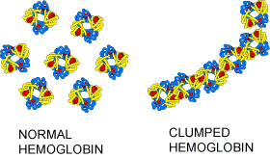 | → | Disk-shaped red blood cells can squeeze through the small blood vessels  → normal health  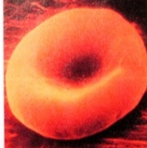
2 copies of the allele  that codes for  sickle cell hemoglobin (ss) | → | Sickle cell hemoglobin  can clump in long rods  in red blood cells. | → | When sickle cell hemoglobin clumps in long rods  → sickle-shaped red blood cells  → clogged small blood vessels + fragile red blood cells  → pain, damage to body organs  + anemia = sickle cell anemia  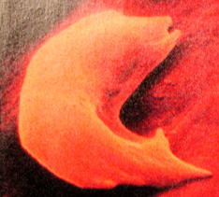

- Circle the arrows in the chart that represent transcription + translation.

